Title of Your Paper

Written by Conor Cook

Working with Nicki Choo

Supervisor: Rouwa Yalda

April 19th, 2024

Contents

Goals & Objective 3

Updated Timeline 3

Team Members Responsibilities 3

Feature List 3

Tools & Technologies 3

SRS Document 3

Functional Requirements 3

Non-Functional Requirements 3

Diagrams 3

UI/UX Modelling 3

Lo-fi Wireframe 3

High-fi Wireframe 4

Usability Testing 4

References 4

# Goals & Objective

## Updated Timeline

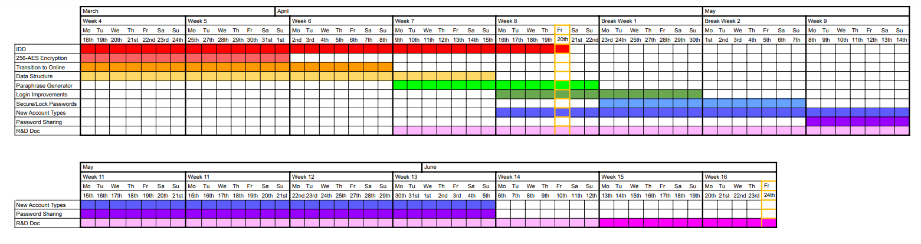

## Team Members Responsibilities

## Feature List

## Tools & Technologies

# SRS Document

## Functional Requirements

## Non-Functional Requirements

## Diagrams

# UI/UX Modelling

## Lo-fi Wireframe

## High-fi Wireframe

## Usability Testing

# References